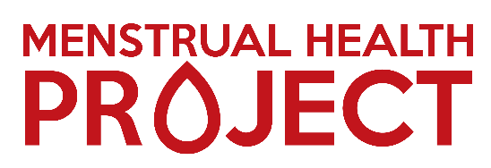
Equal Opportunities Monitoring Form: Volunteers
If you could please answer and provide the following information in each of the criteria box below by marking with an X which category best describes you:

- Which gender best describes how you think of yourself?

Female Male Non-binary
Prefer to self-describe Option to self-describe, please add here:

Prefer not to say

- Gender Identity: Do you identify as Transgender?

Yes No
Option to self-describe, please add here:
Prefer not to say
- Is the gender you identify with the same as your gender assigned at birth?

Yes No Prefer not to say

- How old are you?

- Do you considered yourself to have a disability/disabilities?

Yes No Prefer not to say
- Employment Status

Employer Full Time Employed Part Time Self Employed
Retired Student Not in paid employment
Prefer not to say
- How would you describe your ethnicity?
- How would you describe your sexuality?

Heterosexual Lesbian Gay Bisexual
Other (please specify): Prefer not to say
- What is your religious belief or religion?
- Is there any additional information you would like to provide?
Thank you for completing Menstrual Health Project’s Equal Opportunities form.
We want to ensure that our volunteering roles are available to all, as it is important to us as an organisation that our volunteers who join our team reflect the communities in which we work with. Menstrual Health Project is committed to equality of opportunity in every aspect of the work we carry out.
The data we collect from this form allows us Menstrual Health Project to monitoring successfully equality, diversity and inclusion. We ensure every volunteer who completes this form that their information will remain anonymous and confidential.

